Pakistan J. Zool., vol. 43(3), pp. 489-495, 2011.

Quantitative Profiling of Serum Protein Fractions in Young Obese Human

Afia M. Akram*, Rida Ali, Nabila Roohi and Ayesha Ilyas
Department of Zoology, University of the Punjab, Lahore-54590, Pakistan

Abstract.- Study concerns the investigation of electrophoretically separated serum protein profile of obese (n=18) and control persons (n=9) with ages ranging 20-40 years. Sodium Dodecyl Sulphate Polyacrylamide Gel Electrophoreses (SDS-PAGE) was performed to study the serum protein fractions. The data was quantified by Gene Genius Bio-imaging Gel Documentation system and analyzed statistically using Student‘t’ test to find out the difference of particular protein fractions in obese subjects when compared to controls. Fourteen protein fractions were detected ranging between 152-15 kDa. Protein fractions of 114, 34, 30, and 17 kDa did not vary considerably. Significant elevation in 38, 26 and 20 kDa protein fractions, whereas, significant reduction in 152, 131, 76, 66, 49 and 43 kDa protein fractions was observed. Protein fraction of 15 kDa, observed in normal subjects, failed to manifest in any of the obese individuals. Serum protein profile, suggests that some fraction alterations in obese individuals are strong indicators of their roles in alteration of body mass.

Key words: Obesity, protein profile, SDS-PAGE.

INTRODUCTION

Obesity is a condition having an excess and unhealthy proportion of reserve fat or adipose tissue in the body (Aronne and Segal, 2002) .This excess fat deposition is due to a chronic positive shift of the energy equation resulting from increases in energy input, decreases in energy output, or both (Bray, 1987). Body Mass Index (BMI), defined as weight (kg)/height squared (m²) is the most frequently used measure of weight in relation to height, by the researchers nowadays (Sweeting, 2007).
Many of our sociocultural traditions promote overeating and the preferential consumption of high calorie foods. This may impact energy balance and overweight development (Nicolaou et al., 2009). Obesity alters adipose tissue metabolic and endocrine function and leads to an increased release of fatty acids, hormones, and proinflammatory molecules that contribute to obesity associated complications (Stuart et al., 2003). These disorders include hypertension, dyslipidemia, and glucose intolerance. It is an independent risk factor for, cardiovascular diseases, stroke, type 2 diabetes mellitus, and certain cancers (Rahmouni et al., 2005).
______________________
* Corresponding author: afiaakram@hotmail.com
0030-9923/2011/0003-0489 $ 8.00/0
Copyright 2011 Zoological Society of Pakistan.
Benedek et al. (1984) suggested that the total serum proteins, when calculated in control verses obese subjects were found to be elevated. Elevated levels of inflammation-sensitive plasma proteins (ISPs) fibrinogen, orosomucoid, alpha1-antitrypsin, haptoglobin, and ceruloplasmin, are associated with weight gain (Engstrom et al., 2003). In various studies, Serum albumin and total protein concentrations in the obese were not different from controls (Abernethy et al., 1981). Even the obese subjects showed a markedly decreased serum albumin concentration as compared to non-obese controls (Andersen et al., 1984). In addition, the concentrations of serum alpha 1-acid glycoprotein, growth hormone binding protein (GHBP), ferritin and retinol-binding protein 4 (RBP4), increase with increasing weight. It has been observed that serum alpha-2-macroglobulin and albumin is inversely related to the nutritional intake (Pongpaew et al.,1991; Janke et al., 2006).
Aim of the present study was to assess the effects of obesity and weight gain on serum protein profile of obese persons and their comparison with those of healthy subjects through SDS-PAGE. For this purpose, high and low molecular weight protein profiles were brought under observation to relate the fluctuations in different protein fractions with various health risks in obese individuals. Nutritional intake might be adjusted with low fat (saturated) and high protein diet to observe its influence in lowering the BMI and specific obesity related proteins in these individuals, in future investigations.

MATERIALS AND METHODS

Young healthy males ages ranging 20-40 years, (n=27) were selected from the general population on basis of their BMI and were categorized as obese (BMI > 30 kg/m², n=18) and control (BMI 18.76-21.45 kg/m², n=9). Polyacrylamide gel of 12 % and 6% was prepared, for analysis of low molecular weight and high molecular weight protein fractions respectively. Serum samples were denatured in loading dye with distilled water to prepare the working dilutions for loading onto the gel. Protein marker and each of the serum samples were loaded in separate wells. The gel was electrophoresed at a current supply of 30 mA and 200 V, in a cooling chamber maintained at 4°C until the dye reached the lower end of the gel. The gel was then stained with coomassie blue for 1 hour with constant agitation and destained afterwards until the clearance of blue background.
Stained gels were photographed afterwards and their images were saved on a floppy disk with Gene Genius Bio-imaging Gel Documentation System. Quantification of separated protein fractions was carried out by the same system that provided the data of high molecular weights and percent raw volumes covered by each of the fractions. The data were analyzed using Student t-test and employed in finding the enhancement or reduction and appearance or disappearance of particular protein fractions for comparison between the control and obese subjects.

RESULTS

Variation in the serum protein fractions of obese persons was notable when compared to healthy subjects. An overall comparison of serum protein profiles of both groups evidently showed the expression of fourteen protein fractions ranging between 152-15kDa (Table I).
The 152kDa protein showed a significant (p=0.000) decrease of 26% in obese subjects when compared to controls. Similarly the protein fraction of 131kDa presented a significant decrease of 21 %(p=0.000) in obese subjects when compared to controls. A non-significant increase of 11% (p=0.120) was observed in 114kDa protein fraction in obese persons when compared to healthy subjects. The protein fraction of 76kDa showed significant decrease of 50% (p=0.000) in obese subjects when compared to control.

Table I.- Average percent raw volumes exhibited by various protein fractions in control and obese subjects. Values are Mean ± SEM.

Molecular weight of proteins  (kDa) | Average raw volume (%) of protein fractions |  |  | Percentage difference of protein fractions in obese group
Molecular weight of proteins  (kDa) | Control group | Obese  group |  | Percentage difference of protein fractions in obese group
152 | 09.79±0.28 |  | 07.26±0.19 | 26* ↓
131 | 06.20±0.14 |  | 04.90±0.11 | 21* ↓
114 | 05.27±0.10 |  | 05.83±0.33 | 11 ↑
76 | 15.42±0.18 |  | 07.73±0.10 | 50* ↓
66 | 34.22±0.30 |  | 26.95±0.34 | 21* ↓
49 | 22.26±0.15 |  | 09.31±0.25 | 58* ↓
43 | 13.93±0.25 |  | 11.16±0.24 | 20* ↓
38 | 03.76±0.05 |  | 04.61±0.08 | 23* ↑
34 | 02.23±0.04 |  | 02.18±0.05 | 02 ↓
30 | 04.87±0.54 |  | 04.89±0.10 | 0.5 ↑
26 | 02.17±0.03 |  | 02.60±0.04 | 20* ↑
20 | 01.97±0.07 |  | 02.55±0.05 | 29* ↑
17 | 01.60±0.09 |  | 01.45±0.02 | 09 ↓
↑ Increase, ↓ Decrease, *Significance at p< 0.001

The 66kDa protein was found to be significantly decreased by 21% (p=0.000) in obese subjects when compared to control. A significant decrease of 58 % (p=0.000) was observed in 49kDa protein fraction in obese persons. The protein fraction of 43kDa also showed a significant reduction in obese subjects with a decrease of 20% (p=0.000) when compared to control. The 38kDa protein presented a significant (p=0.000) increase of 23% in obese subjects. The 34 kDa protein fraction did not vary considerably (p=0.490) in obese persons when compared to healthy individuals.
The protein fraction of 30kDa varied insignificantly (p=0.830) in obese compared to control subjects. The 26kDa protein indicated a significant (p=0.000) increase of 20% in obese when compared to control individuals. A significant increase of 29% (p=0.00) was observed in 20kDa protein fraction in obese persons when compared to

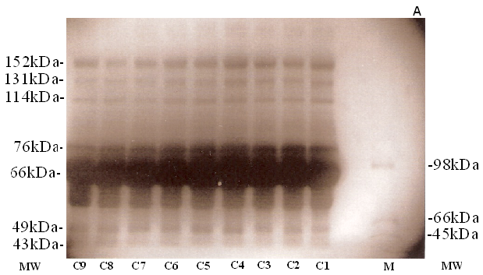 | 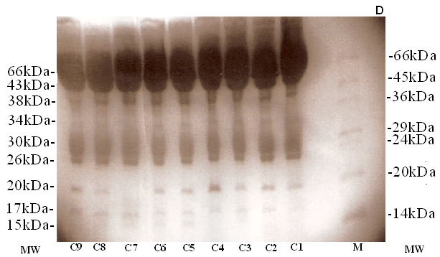
A | D
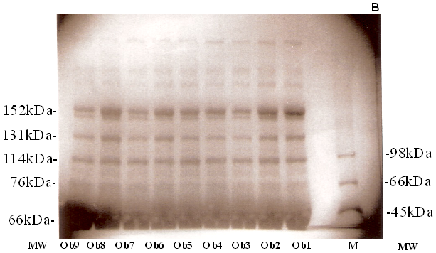 | 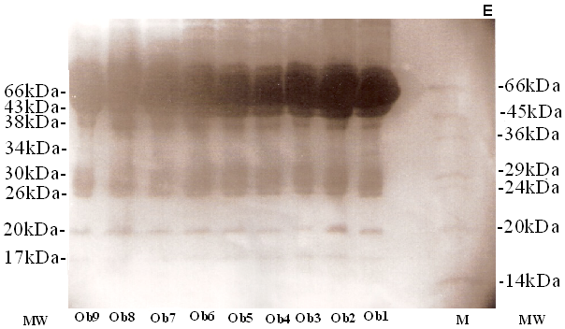
B | E
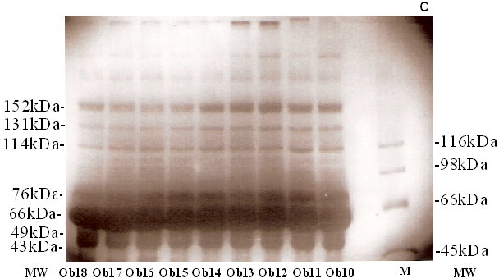 | 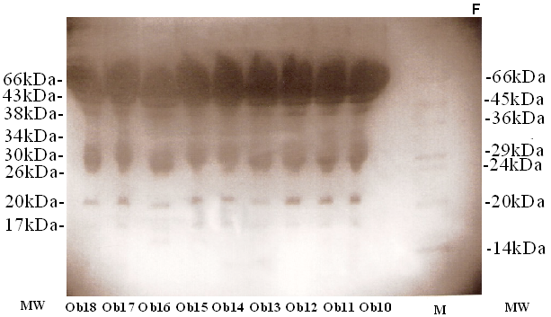
C | F

Fig. 1. SDS-PAGE of serum control subjects (C1-C9) and obese subjects (Ob1-Ob18) on 6% (control A; obese B & C), and 12% (control D; obese E & F), gels. M, protein markers; MW, molecular weights.

control group. The protein fraction of 17kDa did not vary significantly (p=0.150) in obese subjects.

DISCUSSION

Obesity can be defined as exceedingly unnecessary body fat, it is this, not weight which is associated with the comorbid conditions (Craig and Charles, 2009). Although body weight, particularly, at very high levels, tends to be associated with adiposity, weight alone is an insufficient measure of obesity, because it is correlated with height. BMI is commonly used by the investigators that measures excess weight rather than fat (Troiano and Flegal, 1999).
The regulation of energy balance needs to be emphasized, including the neuroendocrine factors that control energy intake, energy expenditure, and the differentiation of adipose tissue resulting from excess calories (Mantzoros, 2009). Changes in the endocrine and metabolic function of adipose tissue are associated with changes in adipose tissue mass. It links increased adiposity to alterations in systemic physiology (Sharma and Staels, 2009).
Obesity may be a low-grade systemic inflammatory disease and is called the “disease of diseases”. Overall health risk is determined not only by the degree of overweight, but by complications and comorbidities that are produced by obesity. For any given weight category, the presence of certain complications moves the individual to the next higher health risk category (Reaven and Banting, 1988). Overweight and obese children and adults have elevated serum levels of C-reactive protein, interleukin-6, tumor necrosis factor-α, and leptin, which are known markers of inflammation. These are closely associated with cardiovascular risk factors and cardiovascular and non-cardiovascular causes of death. This may explain the increased risk of diabetes, heart disease, increased blood pressure, insulin resistance, different cancers and many other chronic diseases in obese (Lakka et al., 2002).
In the present investigation, serum samples of adult individuals, both with normal and elevated BMI, were collected. The protein fractions were studied as an approach to locate and analyze them in subjects with optimal and increased weight. The various protein fractions observed included 150 kDa apolipoprotein (Vezina et al., 1988), 131 kDa ceruloplasmin (Castellani et al., 1999) , 114 kDa C-reactive protein (Jinbo et al., 1998), 76 kDa transferrin (Jiang et al., 1998), 66 kDa albumin (Allen et al., 2006), 49 kDa protein fraction, 43 kDa α-1 acid glycoprotein (Turk et al., 1996), 38 kDa Glyceraldehyde-3-phosphate dehydrogenase (Ryoichi et al., 1996), 34 kDa IGF binding Protein (Kiddy and Hamilton, 1999), 30 kDa Adipocyte complement-related protein (Tsao et al., 2002), 26 kDa TNF-α (Lafontan and Berlan, 2003), 20 kDa retinol binding protein (Senoo et al., 1990), 17 kDa apolipoprotein A-2 (Durbin and Jonas, 1997) and 15 kDa interleukin 2 (Zicaria et al., 1995).
The protein fraction of 152 kDa declined significantly by 26% in obese subjects as compared to controls. Warnke and Kempson (1978) identified this protein as an apolipoprotein and observed that BMI is inversely related to 152 kDa protein fraction. Similarly, 131 kDa protein fraction was found to be significantly lower in obese subjects. It showed a decline of 21% as compared to control group, whereas Cignarelli et al. (1996) studied that subjects with obesity have characteristically higher levels of 131 kDa serum protein. Protein fraction of 114 kDa was found to be increased by 11 % in obese in comparison with normal persons. CRP levels are positively correlated with lipid levels, degree of obesity, and status of cardiovascular diseases (Min Wu et al., 2006). Marjolein et al. (1999) suggested that the higher BMI is associated with higher C-reactive protein (114 kDa) (Jinbo et al., 1998) concentrations, even among young adults aged 17 to 39 years. C-reactive protein may be a marker of inflammation and the extent of obesity and of known increased production of proinflammatory cytokines, tumor necrosis factor- and interleukin-6, in obesity (Barinas-Mitchell et al., 2001). Protein fraction of 76 kDa in our studies was found to be lowered in obese subjects by 50% as compared to normal. However, earlier studies show that obesity, in human beings, has no effect on 76kDa protein fraction (Filla et al., 1998).
The 66 kDa protein fraction was found to be declined by 21% in our study. Warnke and Kempson (1978) observed that BMI is inversely related to serum albumin (66 kDa) levels. Protein fraction of 49 and 43 kDa were also found to be significantly declined by 58% and 20% in obese subjects as compared to normal. Frenais et al. (2001) has also observed a decline in 43 kDa protein fraction in obese people. However, Benedek et al. (1983) suggested that 43 kDa protein concentrations in the obese subjects were double than that of the lean controls. However, 38 kDa was elevated significantly by 23 % in obese individuals, as compared to control subjects. Hoffstedt et al. (2004), in his results suggested that 38 kDa proteins had appeared significantly high in persons with elevated BMI. The 34kDa protein however remained unaltered suggesting that obesity has very little effect on this protein. Juul et al. (2001) also concluded in his study, that 34 kDa protein levels were unchanged in obese persons as compared to the control group.
Protein fraction of 26 kDa exhibited significant elevation of 20% in obese subjects, as compared to the control group. It indicates a strong influence of body mass on serum levels of protein. The 20 kDa protein fraction, showed a significant increase of 29% in serum of obese persons when compared to control individuals. In the same context, Janke et al. (2006), has stated that the level of serum 20 kDa protein (retinol binding protein 4) increases with increasing weight. Insulin resistance occurs under conditions of obesity, metabolic syndrome, and type 2 diabetes. It was found to be accompanied by decreased adipocyte glucose transport protein (GLUT4) resulting in secretion by adipocytes of the serum retinol-binding protein. Thus, establishing a link between obesity and insulin resistance (Wolf, 2007). Protein fraction of 17 kDa did not vary significantly in obese subjects compared to control. In this regard, Zimmerman et al. (1984) stated that no significant changes in plasma 17 kDa protein occur due to weight gain. The protein fraction of 15 kDa was only observed in control group, but failed to manifest in obese individuals. This protein may be regarded as the marker protein of obesity indicating a need of further investigation exploring the role of this protein in maintenance of normal BMI in control subjects.
Analysis of the results of present study, investigating the pattern of serum protein fractions shows that some fractions alterations in obese individuals are strong indicators of their roles in alteration of body mass. The protein fraction of 114 kDa (CRP), 26 kDa (TNF-α) and 20 kDa (RBP4) are positively correlated with obesity and weight gain, whereas, 66 kDa (albumin), 49 kDa and 43 kDa (α-1 acid glycoprotein) protein fraction have negative association with obesity. Further, 15 kDa protein fraction of control group did not manifest in obese individuals, indicating this protein to be a target for further research in obesity.

ACKNOWLEDGEMENTS

The authors gratefully acknowledge all the participants of this study who agreed to give their blood samples to be used in the investigation. Department of Zoology, University of the Punjab is gratefully acknowledged as a major source of funding for the present investigation and there are no conflicts relating to the article.

REFERENCES

Abernethy, D. R., Greenblatt, D. J., Divoll, M., Harmatz, J.S. and Shader, R.I., 1981. Alterations in drug distribution and clearance due to obesity. J. Pharmacol. exp. Ther., 217: 681–685.
ALLEN, L., RODGERS, P. D., mENSAH, S. L. AND SCHWAGER, D., 2006. Inhibition of calcium oxalate crystallization by commercial human serum albumin and human urinary albumin isolated from two different race groups: evidence for possible molecular differences. Urol. Res., 34: 373-380.
Andersen, T., christoffersen, P. and Gluud, C., 1984. The liver in consecutive patients with morbid obesity: a clinical, morphological, and biochemical study. Int. J. Obesity, 8: 107-15.

Aronne, l. j. and Segal, k. r., 2002. Adiposity and fat distribution outcome measures: assessment and clinical implications. Obesity Res., 10: 14-21.
Bray, G. A., 1987. Obesity: a disease of nutrient or energy balance. Nutr. Rev., 45: 33–43.
BARINAS-MITCHELL, E., CUSHMAN, M., MEILAHN, E. N., TRACY, R. P. AND KULLER, L. H., 2001. Serum levels of C-reactive protein are associated with obesity, weight gain, and hormone replacement therapy in healthy postmenopausal women. Am. J. Epidemiol., 153: 1094-1101.
Benedek, I. H., Fiske, W. D., Griffen, W. O., Bell, R. M., Blouin, R. A., and McNamara, P. J., 1983. Serum alpha 1-acid glycoprotein and the binding of drugs in obesity. Br. J. clin. Pharmacol., 16: 751–754.
Benedek, I. H., Blouin, B. A., and Mcnamara, P. J., 1984. Serum protein binding and the role of increased ol-acid glycoprotein in moderately obese male subjects. Br. J. clin. Pharmacol., 18: 941-946.
CASTELLANI, R. J., SMITH, M. A., NUNOMURA, A., HARRIS, P. L. R. AND PERRY, G., 1999. Isincreased redox-active iron in Alzheimer disease a failure of the copper-binding protein ceruloplasmin?. Free Rad. Biol. Med., 26: 1508-1512.
Cignarelli, M., Perogola, G., pica, g., sciaraffia, m., pannacciulli, n., tarallo, m., laudadio, e., tirrisi, e. AND giorgino, r., 1996. Relationship of obesity and fat distribution with ceruloplasmin serum levels. Int. J. Obesit., 20: 809-813.

Craig, s. and Charles, v., 2009. The use of dermal fat grafts for the correction of secondary cleft lip deformities. Plast. Reconstr. Surg., 123: 151-152.
DURBIN, D. M. AND JONAS, A., 1997. The effect of apolipoprotein A-II on the structure and function of apolipoprotein A-I in a homogeneous reconstituted high density lipoprotein particle. J. biol. Chem., 272: 31333-31339.
Engström, G., Hedblad, B., Stavenow, L., Lind, P., Janzon, L. AND Lindgärde, F., 2003. Inflammation-sensitive plasma proteins are associated with future weight gain. Diabetes, 52: 2097-2101.
Filla, m. l., kennedy, m. l. and chen, m. l., 1998. Iron metabolism in genetically obese mice. J. Nutr., 118: 46-51.
FrEnais, r., nazih, h., ouguerram, k., maugeais, c., zair, y., bard, j. m., charbonnel, b., maggot, t. and krempf, m., 2001. In vivo evidence for the role of lipoprotein lipase activity in the regulation of apolipoprotein A1 metabolism: a kinetic study in control subjects and patients with type 2 diabetes mellitus. J. clin. Endocrinol. Metab., 86: 1962-1967.
Hoffstedt, J., Arvidsson, E., Sjölin, E. K. and Arner, P., 2004. Adipose tissue adiponectin production and adiponectin serum concentration in human obesity and insulin resistance. J. Clin. Endocrinol. Metab., 89: 1391-1396.
Janke, J., Engeli, S., Boschmann, M., Adams, F., Böhnke, F., Luft, F. C., Sharma, A. M. and Jordan, J., 2006. Retinol-binding protein 4 in human obesity. Diabetes, 55: 2805-2810.
Jequier, E. and Tappy, L., 1999. Regulation of body weight in humans. Physiol. Rev., 79: 451–480.
Jinbo, t., hayashi, s., naiki, m. And yamamoto, s., 1998. development of C-reactive protein (CRP) assays methods. Vet. Immunol. Immunopath., 61: 195-2005.
Juul, A., Dalgaard, P., Blum, W. F., Bang, P., Hall, K., Michaelsen, K. F., Muller, J. and Skakkebaek, N. E., 2001. Serum levels of insulin-like growth factor (IGF)-binding protein-3 (IGFBP-3) in healthy infants, children, and adolescents: the relation to IGF-I, IGF-II, IGFBP-1, IGFBP-2, age, sex, body mass index, and pubertal maturation. J. Clin. Endocrinol. Metab., 80: 2534-2542.
KIDDY, D. S., HAMILTON, D., 1999. Diet induced changes in sex hormone binding globulin and free testosteron in women with normal or polysistic ovaries: Correlation with serum insulin and insuline-like growth factor-1. Clin. Endocrinol., 31: 757-764.
LAFONTAN, M. AND BERLAN. M., 2003. Issue regional differences in adipocyte biology provide new pathophysiological insights. Trends pharmacol. Sci., 24: 276-283.
LAKKA, H. M., LAKKA, T. A., TUOMILEHTO, J. AND SALONEN, J. T., 2002. Abdominal obesity is associated with increased risk of acute coronary events in men. Europ. Heart J., 23: 706-713.
Mantzoros, C.S., 2009. Nutrition and metabolism: underlying mechanisms and clinical consequences. Humana Press, USA, pp. 41-77.
Marjolein, Visser, Lex, m., bouter, Geraldine, m., mcquillan, mark, h., wener, m. d., tamara, b. and harris, 1999. Elevated C reactive protein levels in overweight and obese adults. JAMA, 282: 2131-2135.
MIN WU, D., CHU, N., SHEN, M. AND WANG, S., 2006. Obesity, plasma high sensitivity c-reactive protein levels and insulin resistance status among school children in Taiwan. Clin. Biochem., 4: 810-815.
Nicolaou, M., Doak, C., van Dam, R., Brug, J., Stronks, k. and Seidell, J., 2009. Cultural and social influences on food consumption in Dutch residents of Turkish and Moroccan origin: A qualitative study. J. Nutr. Edu. Behav., 41: 232-241.
Pongpaew, P., Schelp, F. P., Supawan, V., Prayurahong, B., Mahaweerawat, U., Intrarakhao, C., Sriboonlue, P. and Migasena, P., 1991. Influence of dietary intake on alpha-2-macroglobulin and other biochemical parameters in healthy Thai males. Nutr. Res., 11: 559-565.

Rahmouni, k., Correia, m. l. g., Haynes, w. g. and Mark, a. l., 2005. Obesity-associated hypertension. new insights into mechanisms. Hypertension, 45: 9.
Reaven, G. M. and BaNTING, 1988. Role of insulin resistance in human disease. Diabetes, 37: 595-607.
RYOICHI, I., KATSUYOSHI, S., ATSUSHI, H., PAUL, S., NOBUO, K. AND DE-MAW, C., 1996. Evidence that glyceraldehyde-3-phosphate dehydrogenase is involved in age-induced apoptosis in mature cerebellar neurons in culture. J. Neurochem., 66: 928-935.

SENOO, H., STANG, E., NILSSON, A., KINDBERG, G. M., BERG, T., ROOS, N., NORUM, K. R. AND BLOMHOFF. R., 1990. Internalization of retinol-binding protein in parenchymal and stellate cells of rat liver. J. Lipid Res., 31: 1229-1239.

JIANG, S., HO, M., JIANG, S. AND CHEN, H., 1998. Purified NADPH-sulfite reductase from saccharomyces cerevisiae effects on quality of ozonated macherel surimi. J. Food Sci., 63: 777-781.
Sharma, a. m. and Staels, b., 2009. Peroxisome proliferator-activated receptor γ and adipose tissue—understanding obesity-related changes in regulation of lipid and glucose metabolism. J. Clin. Endocrinol. Metab., 92: 386-395.
Stuart, P., Weisberg, McCann, D., Desai, M., Rosenbaum, M., Leibel, R. L. and Ferrante, A. W., 2003. Obesity is associated with macrophage accumulation in adipose tissue. J. clin. Invest., 112: 1796-1808.
Sweeting, H. N., 2007. Measurement and definitions of obesity in childhood and adolescence: a field guide for the uninitiated. Nutr. J., 6: 32.
Troiano, R. P. and Flegal, K. M., 1999. Overweight prevalence among youth in the United States: Why so many different numbers. Int. J. Obesit., 23: S22-S27.
TSAO, T., MURREY, H. E., HUG, C., LEE, D. H. AND LODISH, H. F., 2002. Oligomerization state-dependent activation of NF-KB signaling pathway by adipocyte complement-related protein of 30 kDa (Acrp30). J. biol. Chem., 277: 29359-29362.
TURK, B. E., JIANG, H. AND LIU, J. O., 1996. Binding of thalidomide to alpha1-acid glycoprotein may be involved in its inhibition of tumor necrosis factor alpha production. Proc. natl. Acad. Sci. USA., 93: 7552-7556.
VEZINA, C.A., MILNE, R.W., WEECH, P.K. AND MARCEL, Y.L., 1988. Apolipoprotein distribution in human lipoproteins separated by polyacrylamide gradient gel electrophoresis. J. Lipid Res., 29: 573-585.
Warnke, e. a. and kempson, r. l., 1978. The nephrotic syndrome in massive obesity. Arch. Pathol. Lab Med., 102: 431-438.

WOLF, G., 2007. Serum retinol-binding protein: a link between obesity, insulin resistance, and type 2 diabetes. Nutr. Rev., 65: 251-256.
ZICARIA, A., TICCONIB, C., PASETTOB, N., LASARDOA, A., SALERNOA, A., PONTIERIA, G. AND PICCONEC, E., 1995. Interleukin-2 in human amniotic fluid during pregnancy and parturition: implications for prostaglandin E2release by fetal membranes. J. Reprod. Immunol., 29: 197-208.
Zimmerman, J., Kaufmann, N. A., Fainaru, M., Eisenberg, S., Oschry, Y., Friedlander, Y. and Stein, Y., 1984. Effect of weight loss in moderate obesity on plasma lipoprotein and apolipoprotein levels and on high density lipoprotein composition. Arteriosclerosis, 4: 115-123.

(Received 31 May 2010, revised 2 November 2010)

